# Neutral Corridor Interpretation of the Cubic

This document presents a new interpretation of cubic equations, connecting classical algebra with cube and circle geometry. Instead of relying on imaginary numbers, the missing 'hidden side' of the cubic can be understood through a circle inscribed in a cube face. This circle provides a real geometric reference — quadrants and curvature — that bridges the gap algebraically filled by imaginary numbers.

## Diagram: Circle Inside Cube Face

By placing a circle inside one face of a cube, touching all four sides, we obtain a geometric reference that provides balance between the cube's straight geometry and the circle's curvature.

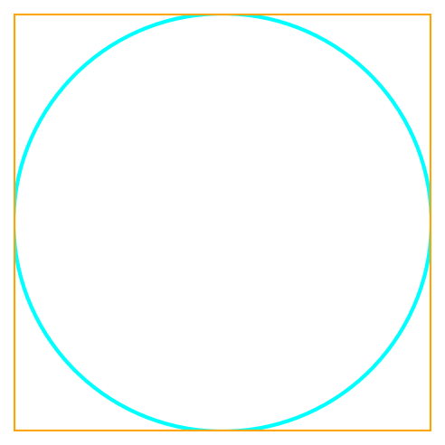

## Historical Context

- Luca Pacioli (1494): Declared cubics impossible to solve.  
- Scipione del Ferro (~1510): Solved special depressed cubics.  
- Niccolò Tartaglia (1535): Found general depressed cubic solutions.  
- Girolamo Cardano (1545): Published full method using cube roots.  
- Rafael Bombelli (1572): Introduced imaginary numbers to handle paradoxes.  
- François Viète (1590s): Showed trigonometric (unit circle) method could solve cubics with three real roots without using imaginary numbers.

## Classical Solution of the Cubic

Cardano's formula often produces square roots of negative numbers, even when the final solution is real. This led to the invention of imaginary numbers, which acted as a bridge between algebra and real solutions.  
  
Example:  
Solve x³ = 15x + 4. The real root is x=4. But Cardano’s formula gives:  
x = ∛(2 + √(-121)) + ∛(2 - √(-121)), which contains imaginary parts that cancel out to give the real solution.

## Trigonometric Method (Unit Circle)

Viète showed that cubic equations with three real roots can be solved using the unit circle and the cosine triple-angle identity:  
cos(3θ) = 4cos³θ - 3cosθ.  
  
By setting t = 2Rcos(θ), the cubic reduces to a linear equation in cos(3θ). This bypasses imaginary numbers entirely and uses geometry of the circle.

## Diagram: Algebraic Cube with Hidden Side

The algebraic cube often requires imaginary numbers as an intermediate step. This diagram shows a distorted cube, where the dashed magenta line represents the 'hidden side' equivalent to imaginary components.

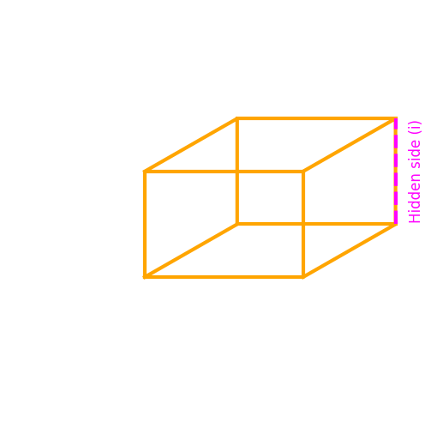

## New Interpretation: Circle Inside a Cube Face

We reinterpret the trigonometric method geometrically:  
- Place a circle inside one face of a cube, touching all four sides.  
- The circle provides a 'neutral corridor' inside the cube face.  
- Quadrants of the circle correspond to angular divisions (90° each), providing a real reference system.  
- The distance from the inscribed circle to cube corners creates a natural number reference.  
  
Thus, instead of invoking imaginary numbers, we can interpret the circle within the cube as supplying the missing geometric element. The cube (rigid geometry) and circle (curvature/π) work together to complete the cubic.

## Physics Analogy: Neutral Corridor

In physics terms, the inscribed circle represents a neutral channel within the rigid cube framework. Just as π is the constant that bridges straight lines and circles, and i is the constant that bridges real and imaginary numbers, this circle-in-cube model symbolizes a 'neutral corridor' that replaces imaginary steps with geometric curvature.  
  
This may provide new insights for warp-tunnel analogies, where neutral voids connect positive and negative fields.

## Conclusion

This interpretation does not replace the algebraic invention of imaginary numbers historically, but it offers a new geometric–physical analogy: the inscribed circle within the cube face represents the hidden algebraic dimension of the cubic equation. This visualization links cube geometry, circle quadrants, and algebraic solutions into a unified framework.